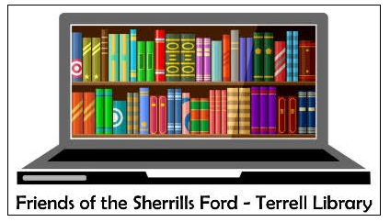
2022-2023 Membership Form
Friends of the Sherrills Ford-Terrell Library
Consider following us on Facebook or Instagram to keep current on planned activities
http://www.facebook.com/FOSFTL or @sherrillsfordfol
How do you sign up? We would love to have you join “The Friends” and we can’t wait to meet you.
Being part of this organization is an excellent way to support your community.
Simply choose your donation level and fill out the below information.
- Donations above our annual $10 Family Membership cost fund the bulk of our programs!
- We intentionally keep our Membership cost low and affordable.
- Revenues from Membership cover roughly 25% of our annual operating budget, so we very much appreciate and rely on donations beyond the basic membership cost.
- While most of our funds are used for our Sherrills Ford-Terrell community, a portion of our donations may be used periodically to support the Catawba County Library Endowment to ensure consistent and critical financial support beyond that provided annually by our state and local governments.
- Annual Renewal – Thank You  - New Membership – Welcome! | - $10 Family Membership Cost  - $50 Sponsor Donation  - $100 Patron Donation  - Other Donation Amount $_______  Checks made payable to: Friends of the Sherrills Ford-Terrell Library
Name: _________________________ (as you wish used on our FOSFTL nametag)
Address: ______________________________________
______________________________________ Zip Code: ___________________
Phone: (_____) ____________________ E-mail: _____________________
You can drop off the membership form and check while at the library or send by mail to:
FOSFTL
9154 Sherrills Ford Road
Terrell, NC 28682

Friends of the Sherrills Ford – Terrell Library (FOSFTL)
If you are interested in any of the Volunteer Opportunities below, put a check next to them, and we will get back to you. Teens may be eligible for school volunteer requirements.
- Officer Role – President, Vice-President, Treasurer or Secretary (2-year term)
  - Nominating Committee to help us recruit talented Officer and Board Members
- Fundraising Committee to help us create a strategic approach to fundraising
  - Book Bonanza Committee helps us ensure ongoing supply of books
  - Gift Basket Committee helps us assemble gift baskets with others throughout the year
- Holiday and Special Event Support helps with one of our special events, such as our children’s holiday party
- Literacy Program supports our program in the First and Second Grades by helping select books, assemble reading packets or reading in one of our classrooms
- Membership Committee helps with outreach for members, greets and staffs our event tables
- Program Committee helps generate program ideas and implements those selected
- Refreshment Team organizes and provides refreshments for one of our events
- Roadies Team helps set up and clean up at our events
- Publicity Committee helps us coordinate and expand how we publicize our work
- Art Show Committee sets up displays of school artwork throughout the year
- Little Free Library Committee helps facilitate this new venture with Little Free Libraries throughout our community
- Friendly Krafts 4 Kids Committee creates, organizes and stocks the “Take and Make” literacy based kits for younger patrons of the library

